

**ALAGAPPA COLLEGE OF TECHNOLOGY**

**ANNA UNIVERSITY-600025**

**NM Assignment / Digital Marketing**

| NAME | REG.NO | Naan Mudhalvan ID |
| --- | --- | --- |
| Vidhya R | 2020308035 | 61945CB7B54236EA61D4796ED4713D69 |

**1. Create a blog or website using Blogpost Customize the theme design and post new article with 500 words.**

<https://simplyfashionirl.blogspot.com/2023/10/simple-tips-to-elevate-your-fashion-game.html>

**2. Create a New Facebook Business Page and post one social media poster for your brand.**

<https://www.facebook.com/people/Mocha-magic/61553090992824/>

**3. Create and design a social media advertisement poster using canva.**

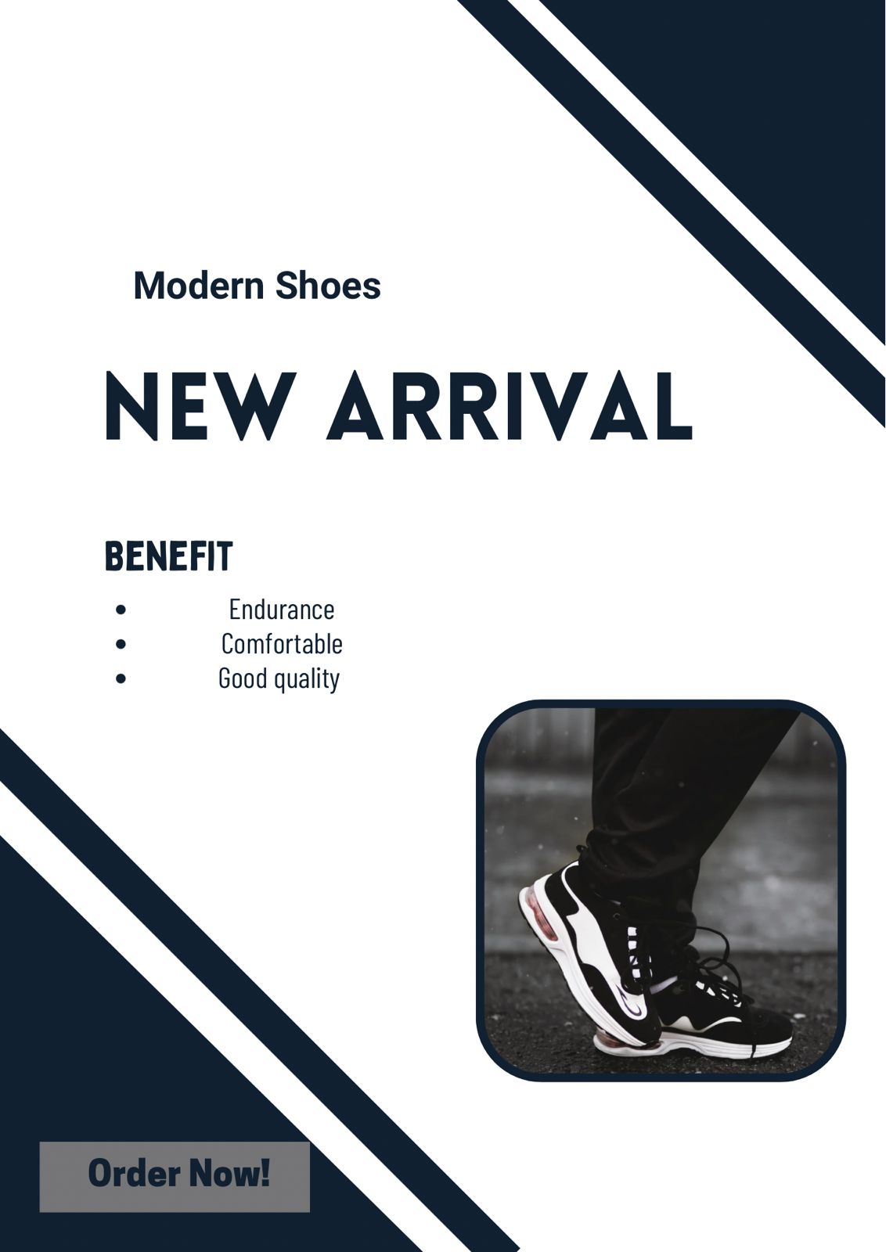

**4. Create email newsletter design using MailChimp or canva tool.**

